**Infrared Sensor based Automatic People Counter**

Theogene Bimenyimanaa,, Xiangyu Maa, Chanpreet Singha, Mirarash Pajoom,a

a School of Information Technology, Carleton University, Canada

**ABSTRACT**

We developed the infrared sensor based automatic people counter that counts number of people entering or exiting an entry gates or doors of any facility such as gym, entertainment hall. The developed solution uses two sets of infrared (IR) sensors consisting of an IR LED and Photo diode placed at two ends of the entrance room, and output from each sensor is fed to the microcontroller before being stored to the local server. The html page has been developed in order to give access to the community user who will have access to the counter number of peoples present at a location where they are intended to visit. Compared to existing cameras based people counters; our solution provides bidirectional people counting , privacy preserving and very inexpensive people counter that could be used in gym, retail shops.

*Keywords*: Infrared sensor; Microcontroller; Counter ,Server; HTM

# 1. Introduction

An automatic people-counting system in real time is important in several application areas where the activity of people needs to be analyzed or monitored. If we get the number of visiting people for a period, it is easy to manage and control people and special areas such a building, a park, and soon. Today motion detection systems are a best key to address significant problems like surveillance, securing the environment, urban traffic, and it could be used to help people to decide to where and when they should spend their times or to guards, police or help aid groups to achieve their targets more efficient. In recent years, the recognition of human motion has become an important project, and this is the case in most areas of machine vision and human communication with the computer. Despite the extensive research done in this field, this problem has already been addressed as an unresolved challenge in machine vision. The use of local spatial-temporal methods in recent years has been highly regarded and has been able to increase the accuracy of human motion detection accuracy. Literally, movement recognition in humans is accomplished with the help of two different inputs. In sensor based mode[1,2,3,7,8], sensors that are installed in different parts of the building or body, are receiving the motion inputs .This issue varies depending on the number and location of the sensors. The motion recognition system based on the sensor input usually works on the basis of which sensor is activated to perform an activity. Then, the system combines the conditional probabilities of these sensors to identify the various movements and decide what action has been taken.  
  
The second method is to extract features using the camera [4, 5]. The recognition of human behavior, as an effective research topic in computer vision, has been researched since 1980. In the past decade, scientific research has focused mainly on learning and detecting behaviors from video sequences derived from a simple camera, and can be found in rich resources in a wide range of disciplines, including computer vision, pattern recognition, machine learning, and signal processing. . Although over the years, many progress have been made in extracting features, feature representations and classifications, identifying human behavior remains a major challenge In this context, there are many problems, such as doing different kinds of actions by different people and other variations such as cost, privacy concerns, latency, complexity problems, motion similarities, moving animated backgrounds, camera movement, and different viewing angles. In recent years, with the reduction of access costs, range recorders have been used more than before but still have a lot of issues.  
The latest progress in this field is the mobile augmented/virtual reality (AR/VR) , real-time 6-Degree of Freedom (DoF) motion tracking is essential for the registration between virtual scenes and the real world. However, due to the limited computational capacity of mobile terminals today, the latency between consecutive arriving poses would damage the user experience in mobile AR/VR. To address all problems we will develop a real-time people counting solution that is easier to deploy compared to similar solutions, privacy preserving and very inexpensive by using IR array sensor.

# 2. Related Research Works

People counting techniques have been applied in many public places with entrances, such as supermarkets, subways and bus stations. The people flow data of these scenes can supply useful information for public security, marketing decision and resource allocation. Several systems have been developed for these purposes. Most of these systems are based on a camera. Bin Li et al (2014) [4] proposed a method based on head detection and tracking to evaluate the number of people who move under an over-head camera. The proposed method first utilizes an effective foreground extraction method to obtain foreground regions of moving people, and some morphological operations are employed to optimize the foreground regions. Then it exploits a local binary pattern (LBP) feature based Adaboost classifier for head detection in the optimized foreground regions. After head detection is performed, the candidate head object is tracked by a local head tracking method based on Meanshift algorithm. Based on head tracking, the method finally uses crossing-line judgment to determine whether the candidate head object will be counted or not. Experiments show that their method can obtain promising people counting accuracy about 96% and acceptable computation speed under different circumstances. Red Green Blue (RGB) cameras based solutions can have relatively high accuracy, but cameras are privacy invasive. Even if a camera does not stream videos, it can be compromised while connected to the Internet and raise privacy concerns. Chenglin et al (2011)[3] designed a motion states recognition algorithm based on Doppler effect in which the system algorithm can estimate the number of people who want to go across the automatic door. They assumed that the speed of ultrasound is c in the air, the relative motion between human and the sensors is v , the frequency of ultrasonic pulse sent by this system is f , the frequency of echo pulse is *f*' and the frequency difference between f and *f* ' is  Δf . According to Doppler Effect:

(1)

(2)

To sum up, we can use Δf to make the judgment. If, it belongs to the first kind of states. We can judge that human beside the door are stationary. If Δf andis bigger than a threshold, it belongs to the second kind of states. We can determine that there is someone who wants to go across the door. If Δf andis bigger than a threshold, it belongs to the third kind of states. We can determine that there is someone who wants to go away from the door. If is smaller than a threshold, it belongs to the fourth kind of states. We can determine that there is someone who is just passing by the door. The drawback of ultrasonic sensor based people counting method is that it requires a significant amount of training to achieve reasonable occupancy estimation accuracy. Besides, ultrasonic waves usually are not pet-friendly. High-resolution thermal imagers are accurate; but price for commercial thermal imagers starts at $250 which is prohibitively expensive for large scale deployments. Hessam Mohammadmoradi (2017) [1] used a low resolution (8*×*8 pixels) IR array sensor to count the number of people inside a room. To do so, they deployed an IR array sensor on sides or top of the doorway and counting entrance and exit events. The solution extracts and tracks humans from captured IR images using their temperature difference compared to the background. Their solution achieved 93% accuracy in occupancy estimation in real-time.

The existence people-counting systems also have the problems of power (including a wire electric power) and network connection to be established in some places such as mountain area where existence network are not set up and cannot well receive a radio wave . To solve the problem, Byung-rak Son et al 2007[2] developed a system which consists of Sensor Node, Sink Node or Gateway, Server and Client. The sensor node consists of a people-counting sensor and an environment sensor. These sensor nodes constitute a wireless sensor network and make an exchange with each other’s information. The exchanged data by these sensor nodes is sent to a gateway through the wireless sensor network. For people-counting in the mountain area, their system uses two photo-beam sensors, a big rechargeable power and a solar power. Their people-counting method can automatically count the number of incoming and outgoing people at a special point in real time. Moreover, the environment sensors measure environment information at the mountain area, and constitute the wireless sensor network with photo-beam sensors. They found that the developed system is suitable within 200 meters for effective wireless communications in Korea Mountain. When the width of a path up a mountain is within 1.5m, the reliability of people-counting in our system is over 90%. The number of visiting people and the measured environment information are used to manage and control the mountain network.

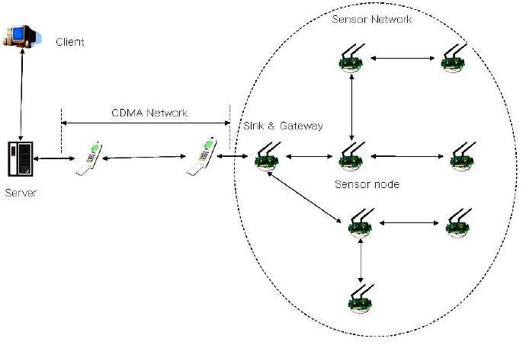

Fig. 1: system configuration [2]

# 3. Gaps in Related works

RGB cameras based people counting method is accurate but often raises privacy concerns and may not be deployed in many residential and commercial buildings but even if a camera does not stream videos, it can be compromised while connected to the Internet and raise privacy concerns.

Ultrasonic sensor based people counting method use the system algorithm that can estimate the number of people who want to go across the automatic door based on Doppler Effect. The method measures features like people’s height to count entrance and exit require a significant amount of training to achieve reasonable occupancy estimation accuracy. Besides, ultrasonic waves usually are not pet-friendly. High-resolution thermal imagers are accurate; but price for commercial thermal imagers starts at $250 which is prohibitively expensive for large scale deployments.

Break-Beam sensors based people counting method use two sensors for counting people, one being the transmitter and the other one being the receiver. The transmitter unit continuously emits an IR wave in a straight line to the receiver unit. If someone passes through this line, the receiver detects a break in the line and considers it as a human passing event sensor are the cheapest people counting solution available commercially. They use breaks in active IR signals to detect objects when they pass through a door and break the signal. However, there are tight restrictions regarding the placement of Break-Beam sensors at the doorway (specific height and pointing directly to each other) that make them hard and even impossible to deploy in some scenarios.

Infrared images based people counting method extracts and tracks humans from captured IR images using their temperature difference compared to the background. It uses a GridEYE sensor for counting people GridEYE is mounted on top of the ceiling and records IR images and n the best mounting configuration, GridEYE can cover a 2.5m*2.5m area which means for larger rooms, multiple GridEYEs are required.

Different technologies and sensing platforms have proposed for accurate and efficient people counting. However, these solutions are privacy invasive, expensive, hard to deploy. In our project, we intend to use both break bean sensor and infrared sensor to solve privacy and high cost problems. The break beam sensors will be usedon sidesof the doorway or entrances while IR array sensors will be placing on top of a door in order to handle the crowded scenarios when multiple people move simultaneously.

# 4. Research questions

1. Does existing counting systems provide real time/ inexpensive people counting?
2. Develop a real-time people counting solution that is easier to deploy compared to existing solutions, privacy preserving and very inexpensive by using break beam sensors and IR array sensor.
3. Evaluate our solution by deploying the system in academic building, gym centers, parking areas containing revolving doors and non-revolving doors.
4. Compare and contrast our solution to the previous method and decide which one is appropriate according to flexible usability.
5. Perform a range of micro-benchmarks to understand the characteristics of the sensor and analyze its performance under different deployment scenarios.

**5. People counting system Market analysis**

1. **Market Scenario:**

The global people counting system market is growing because of the high accuracy and reliability in monitoring and counting entrance and exit traffic separately, while excluding carts, children, and strollers. People counting system consists of people counter device that measures the number and direction of people traversing any entrance or a passage per unit time. This device is widely used in the entrances of buildings to record the total number of visitors. People counting systems have usage in different industry domains. Along with high adoption of cloud and internet of things the global people accounting system is growing explosively. The adoption of global people counting system market is used mostly in crowded places such as shopping malls and concerts, other than their conventional job of calculating footfall; they are used for crowd management and monitoring of high-traffic areas. Their additional uses include fire management and energy usage optimization.

The global people counting system is segmented on the basis of position, type, connectivity, product and application. The connectivity segment sub-segmented into wired and wireless connectivity. The wireless technology is low cost, reloadable bidirectional in or out movement detector. The key advantages of wireless technology simultaneous multiple target detection, smart passage recognition (e.g., detects stops, direction change and turning back) [9].

**Key Findings:**

* The global people counting system market is expected to reach USD ~1,100 million by 2022, growing with approximately 14% of the compound annual growth rate (CAGR) during forecast period 2016-2022.
* By Type, unidirectional people counting system is dominating the market and is expected to reach USD 600 million by 2022.
* By Connectivity, Wireless is expected to grow with 14% CAGR during forecast period 2016-2022.
* North America is expected to dominate the market of people counting system market throughout the forecast period.
* By Application- Transportation sector is dominating the market and is expected to reach USD 300 million by the end of 2022.

**b) Segments:**

Global People Counting System Market for segment on the basis of position, type, technology and application.

**People Counting System Market by Position:**

* Overhead beam
* Horizontal Beam

**People Counting System Market by Type:**

* Bidirectional
* Unidirectional

**People Counting System Market by Technology:**

* Wired
* Wireless

**People Counting System Market by Application:**

* Transportation
* Retail
* Banking & Finance
* Hospitality
* Sports & Entertainment
* Government

Others

**Key Players:**

The prominent players in the global people counting system market are Iris GmbH, ShopperTrak, Retail Next, Inc., Axis Communication AB, FLIR Systems, HELLA Aglaia Mobile Vision GmbH, Infrared Integrated Systems Ltd, IEE S.A., Eurotech SpA and Traf-sys, Inc. among others.

**c) Regional Analysis:**

The regional analysis of global people counting system market is being studied for region such as Asia pacific, Americas, Europe and Rest of the World. Rapid evolution of IOT across different industries has driven the market of global people counting system market. The North America region to dominate the market of global people counting system. Asia-Pacific is the leading region in the people counting system market. Retail stores, supermarkets, and shopping malls are the leading application areas in the Asia-Pacific people counting system market. The increasing number of retail stores is one of the major driving factors for the growth of the market in Asia-Pacific. Asia Pacific will be a prominent market throughout the forecast period. Countries such as China, India, Japan, and Singapore will be the sites of high growth rate throughout the forecast period.

**Intended Audience**

* Investors and consultants
* System Integrators
* Government Organizations
* Research/Consultancy firms
* Technology solution providers
* Hardware manufacturers
* Entertainment Sector
* Sports Organization

The report for **People Counting System Market** of Market Research Future comprises of extensive primary research along with the detailed analysis of qualitative as well as quantitative aspects by various industry experts, key opinion leaders to gain the deeper insight of the market and industry performance. The report gives the clear picture of current market scenario which includes historical and projected market size in terms of value, technological advancement, macro economical and governing factors in the market. The report provides details information and strategies of the top key players in the industry. The report also gives a broad study of the different market segments and regions.

**6. Requirement analysis**

**Functional Requirements:**

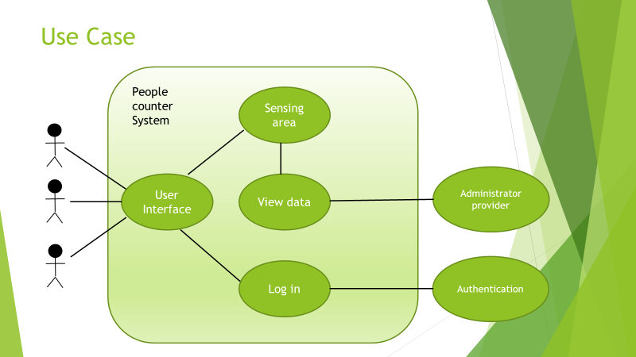

Sensors:

|  |  |  |  |  |  |
| --- | --- | --- | --- | --- | --- |
| R# | Name | Description | Objective | Input | Output |
| 1.1 | Thermal Sensor | A sensor that detect object by temperature | It shall identify the number of people in the sensing area | People who are walking by, sensing from the top of the door | Data output on the server for every time frame |
| 1.2 | Beam Sensor | A sensor that detect object by beam breaking | It shall identify the direction of the traffic | People who are walking by, sensing from the sides of the door | Data output on the server for every time frame |

Data Communication:

|  |  |  |  |  |  |
| --- | --- | --- | --- | --- | --- |
| R# | Name | Description | Objective | Input | Output |
| 2.1 | Ethernet IEEE802.3 | A wired communication | It shall connect between sensors to microcontroller and microcontroller to the server | Analogue to digital values | Digital data |
| 2.2 | HTTP/JSON | A wireless communication | It shall connect between server to user interface | Digital data | Digital data |

User Interface:

|  |  |  |  |  |  |
| --- | --- | --- | --- | --- | --- |
| R# | Name | Description | Objective | Input | Output |
| 3.1 | Hypertext Markup Language | Files that are stored in html format | USER INTERFACE | <html>  <head>  <title>Page Title</title>  </head>  <body>  <h1>This is a Heading</h1>  <p>This is a paragraph.</p>  </body>  </html> | This is a Heading  This is a paragraph. |
| 3.2 | Hypertext Preprocessor | Files that are stored in php format | Php server-side scripting language helps for connection to data base | <html>  <body>  <?php  echo "My first PHP script!";  ?>  </body>  </html> | My first PHP script |
| 3.3 | Javascript | Files that are stored in js format | JavaScript to program the behavior of web pages | <html>  <body>  <h2>My First JavaScript</h2>  <button type="button"  onclick="document.getElementById('demo').innerHTML = Date()">  Click me to display Date and Time.</button>  <p id="demo"></p>  </body>  </html> | My First JavaScript  (Click me to display Date and Time.) |
| 3.4 | Bootstrap Cascading Style Sheets | Files that are used on web page for styling UI | describes how HTML elements are to be displayed | <link rel="stylesheet" type="text/css" href="mystyle.css"> | (show feature described in mystyle.css) |
| 3.5 | MySql | A relational database model | Helps to store database information from the UI | mysqlconnection <- dbConnect()  result <- dbSendQuery(mysqlconnection, "select * from actor")  data.frame = fetch() | None |

Programming tools:

|  |  |  |  |
| --- | --- | --- | --- |
| R# | Name | Description | Objective |
| 4.1 | C++ | A programming language | It shall programme the microcontroller |
| 4.2 | R | A programming language | It shall programme offline data framework |
| 4.3 | Proteus | A visualization tool | It shall perform simulation |

5. Logging: System should allow user to access current data status (excel sheet) and count history by using smart phone.

6. Calculation: System should count if people are in threshold sensing area in the doorway.

**Non-functional Requirement:**

7. Small weight

8. Simple adaptation to different cross-section

9. Low cost: System should be inexpensive by using low cost material

10. Non-intrusive, people should be located without their intervention, so that it guarantees them so that their behavior is not affect by the system.

1. **People counting system architectural and component design**
   1. **System architecture**

The framework of the system is as presented in figure 1, where beam sensors will be attached on the two sides of door while passive infrared sensor (PIR) will be mounted at the top of the door. Both beam and (PIR) sensor will be connected to the microcontroller through Ethernet cables and the microcontroller will be programmed for the counting algorithm, data will be transmitted to the server as shown in figure 2. The number of people can be accessed from server anywhere at any time on a PC, tablet or smart phone from the cloud or the local server to which the data is uploaded, if the administrator (group members) shared it other users.

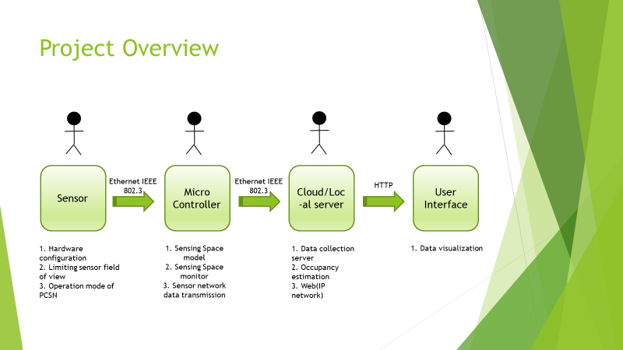

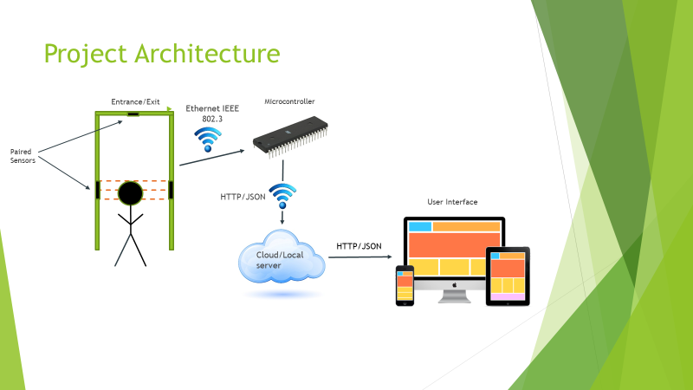

Fig.2. Project Architecture

**People counting sensing part**

**a) Beam sensor on sideways of the door.**

We will use two sensors for counting people, one being the transmitter and the other one being the receiver. **The transmitter unit continuously emits an IR wave in a straight line to the receiver unit**. If someone passes through this line, the receiver detects a break in the line and considers it as a human passing event sensors are the cheapest people counting solution available commercially. Beam sensors will use breaks in active IR signals to detect objects when they pass through a door and break the signal. However, there are tight restrictions regarding the placement of Break-Beam sensors at the doorway (specific height and pointing directly to each other.

To count visiting people, we set up a pair of photo-beam sensor node. Each photo-beam sensor node will be established on the photo-beam sensor 1 and the photo-beam sensor 2 of the interface board**.** If it is checked on the photo-beam sensor 1 to the photo-beam sensor 2, that means ‘incoming’. If it is checked on the photo-beam sensor 2 to photo-beam sensor 1, that means ‘outgoing’. Therefore, the photo-beam sensors automatically are able to count the number of incoming and outgoing people in real time. Usually, a width of the sensing should be made narrow and we will limit a width of sensing area up **1.5m.**

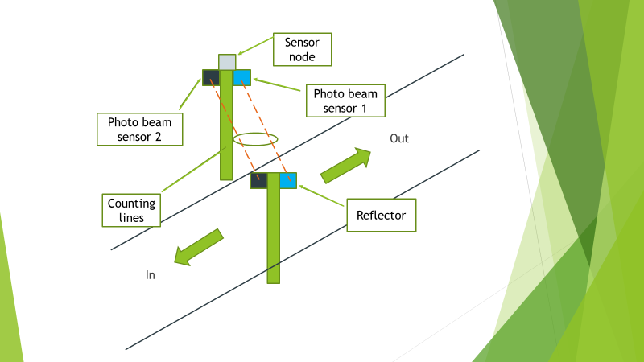

**Fig.3.** A situation for two beam sensor mounted on the door sideways.

1. **Passive infrared sensor basic**

The main idea is deploying an IR array sensor **on top** of the doorway and counting **entrance and exit events**. The solution extracts and tracks humans from captured IR images using their temperature difference compared to the background.

PIR sensors use a pyroelectric sensor to measure infrared radiation. When passing through the sensor’s field of view, emitted body heat of a person causes the sensor to trigger. The main characteristics of PIR sensors are angle, shape, and radius of the field of view, power consumption as well as their mask time after triggering.

Each time that a person passes the sensor’s field of view, a trigger is expected due to emitted body heat in the infrared light spectrum. The toggling PIR sensor component triggers a wakeup of the micro-controller. The micro-controller composes a data packet and forwards it to the wireless communication module for subsequent transmission. The wireless communication unit sends the message through the wireless channel to a remote access. 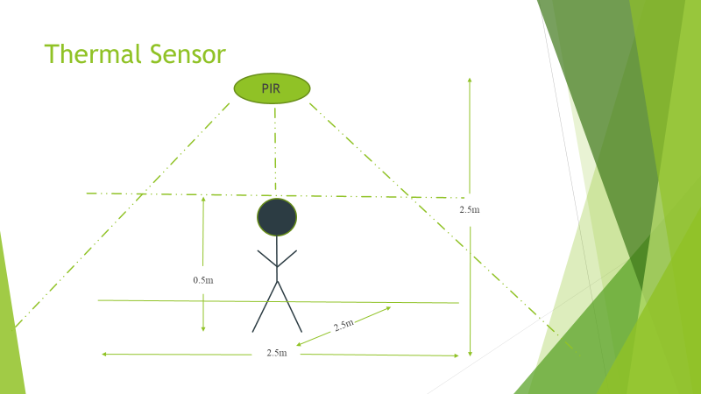

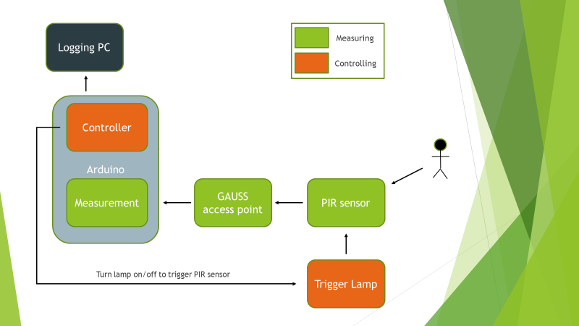

Fig.4. Schematic test set up for passive infrared sensor (PIR).

* 1. **User access part**

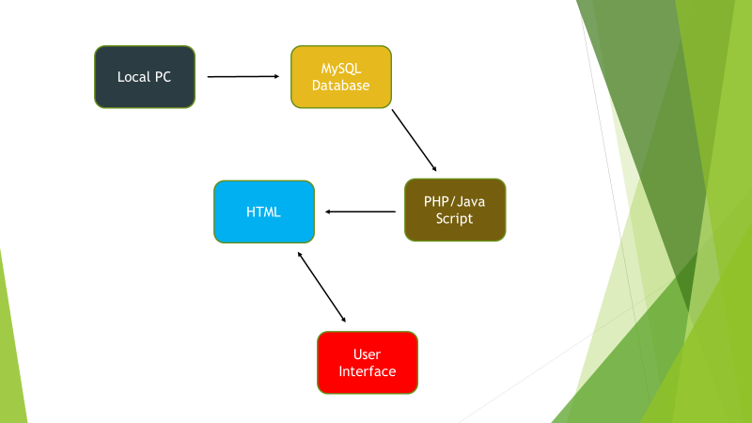

Fig.5. User interface setup

1. **Prototype of IR sensor based people counting system**
   1. **People counter circuit principle.**
2. **Sensing circuit.**

In this project we used IR transmitter (IR LED) and reflective IR sensor (photodiode) and are configured in two ways (transimissive IR sensor and receiver IR sensor) . In the transimissive IR sensor configuration, the IR receiver and IR transmitter are placed one facing another, so that IR receiver always detects IR transmitter (IR LED) until an object is placed between them. In the reflective configuration, the IR receiver and IR transmitter are placed side by side, so when an object is placed on front of the sensor , the rays emitted by reflector is received by the receiver.

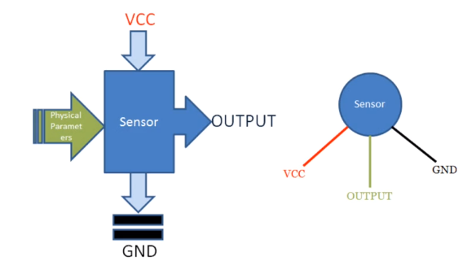

Fig.6. sensor operation

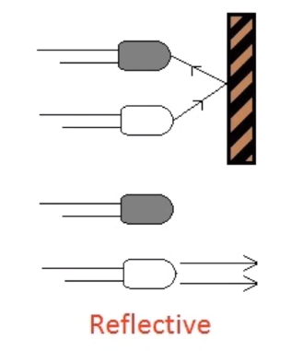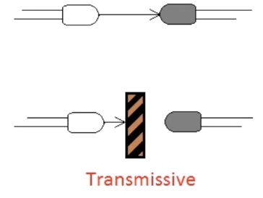

Fig.7.IR transimissive and Reflective configuration mode



Fig.8. IR transmitter and receiver circuit.

The circuit works on the principle of IR sensing. Infrared or simply IR Sensors are devices that work with Infrared Light Source and a Photo Detector like a Photo Diode or a Photo Transistor that act as a Transmitter and Receiver respectively. In this project, we have used an IR LED as the IR Transmitter and a Photo Diode as the IR Receiver. Two sets of IR sensors consisting of an IR LED and Photo Diode are placed at two ends of the entrance of a room. Output from each sensor is fed to the microcontroller. In normal operation, IR light from the LED would not fall on the Photo Diode as it is a Reflective type IR Sensor. The output from the sensor would be a logic LOW signal in this case. In case of any interruption (due to any person crossing the path), the Photo Diode would start receiving the IR Light and start conducting. As a result, the output from the sensor would be a logic HIGH signal. The transition from low to high, for each sensor pair is detected by the microcontroller and accordingly the count would be increased or decreased.

The sensor circuit is designed by selecting appropriate value of resistors for both the LED and the Photo Diode. A 150Ω current limiting resistor is placed in series with the IR LED. Photo Diode is connected in reverse bias with a series resistor of 10KΩ. Photo Diode and 10KΩ Resistor form a potential divider and the output is given to the non – inverting input of the Operational Amplifier (Op – Amp). A 10KΩ POT is connected at the inverting input. This POT can be adjust in order to change the sensitivity of the IR Sensor. A 16 x 2 LCD Display is used to display the count values. The data line of the LCD are connected to PORT1 Pins of the Microcontroller.

The Control Pins i.e. RS, RW and E are tied to P3.6, GND and P3.7 pins. A 10KΩ POT is connected to contrast adjust pin i.e. Pin 3 of LCD.

Another important aspect of the design involves designing the oscillator circuit and the reset circuit. The oscillator circuit is designed by selecting an 11.0592 MHz quartz crystal and two ceramic capacitors – each 33pF. The reset circuit is designed by selecting a resistor of 10KΩ and an electrolyte capacitor of 10µF to ensure a reset pulse width of 100ms and reset pin voltage drop of 1.2V.

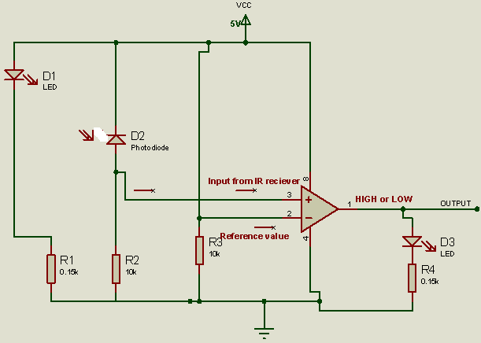

Fig.9. Final Infrared (IR) sensor circuit

1. **Programmer**

We used Keil IDE software for Source code edit and compiler while Willar Programmer will be used to transfer the machine code to microcontroller. Proteus is being used for simulation purpose before hardware implementation.

* 1. **Working principle of our people counting solution**

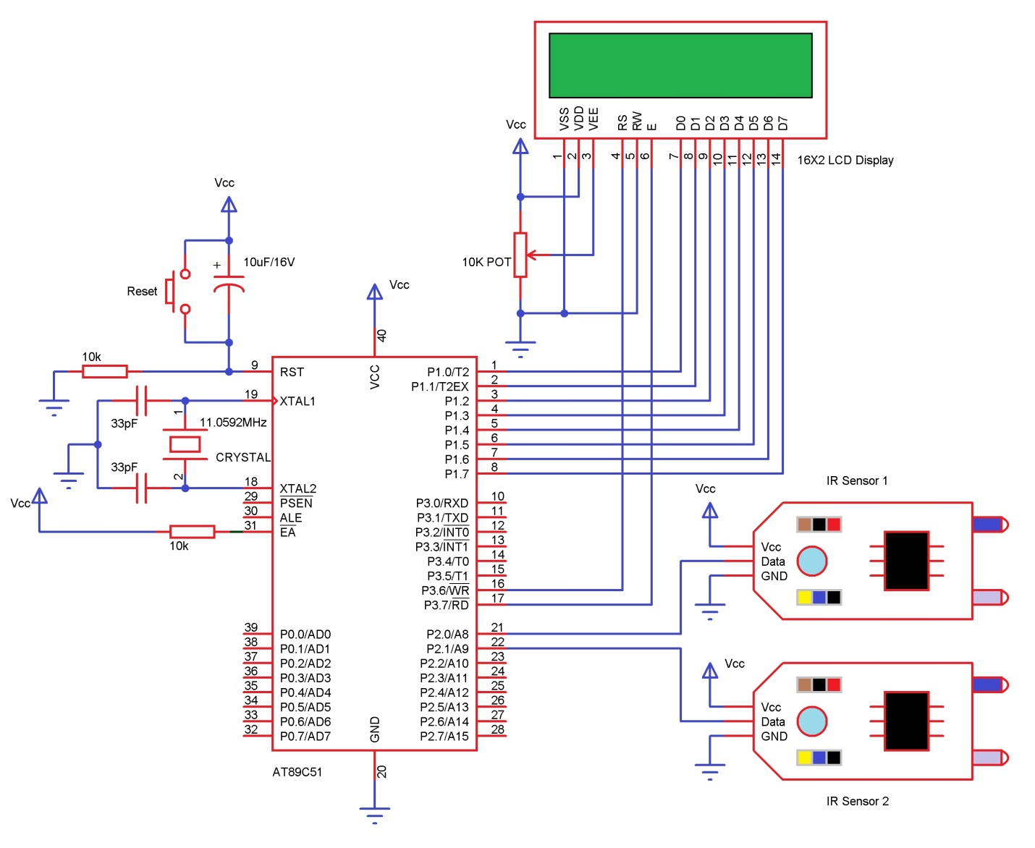

Fig.10. Circuit diagram of the people counting system

**Algorithm I** IR sensor based people counter

* P1 connected to LCD data pins.
* Pins P3.6 and P3.7 to rs and e pins of LCD display.
* Pins P2.0 and P2.1 are connected to the data pins of the IR sensor.
* Usually LCD requires ascii values as an input, to display the characters and numbers. In order to display numbers from 0 to 9, we need to send ascii values to the lcd from 48 to 57.
* Initializing all used function globally.
* Delay function which produce approx of 1ms delay if d is 1.
* If d is 1000 it produces approx 1sec delay.
* The function will hold a set of primary commands to display which is used to initialize it.
* Display function is used to give data to the lcd, which is to be displayed.
* String function is used display the string characters (words).
* This function will work by keep on calling the display function to display the individual character in a word, until it detects '/0'. usually an end of string (word).
* The function will hold a set of primary commands to display which is used to initialize it.

NOTE: we can’t send the 2 or more digit values directly to the LCD display. like, 22, 234, 4321, etc....

* To overcome this problem this _view_ function will split the 2 digits value (as this project concentrate only values from 00 to 99) separately and send them one by one to the display function.
* As the IR sensor connected to PORT2, to detect the 1 (HIGH) output from the IR sensor( if an person is crossing the entry door), we initially make this PORT as 0 (LOW)if no person is closing.
* Start by Call init function to initialize the display.
* As the count value was 0, the view function will make the LCD to display 00 initially.
* **Once if, s1 (sensor1) detects high follow by s2 then the value will increment. (entering the room)**
* **Unless if, s2 detects high follow by s1 then the value will decrement. Leaving the room**
* **while** (1) {
* **if** (s1 == 1) {
* **while** (s2 == 0)**;**
* **if** (count != 99)
* count = count + 1**;**
* **while** (s2 == 1)**;**
* **view** (count)**;**
* }
* **else if** (s2 == 1) {
* **while** (s1 == 0)**;**
* **if** (count != 0)
* count = count - 1**;**
* **while** (s1 == 1)**;**
* **view** (count)**;**
* }
* }
* **Unless if, s2 detects high follow by s1 then the value will decrement. Leaving the room**
* **while** (1) {
* **if** (s1 == 1) {
* **while** (s2 == 0)**;**
* **if** (count != 99)
* count = count + 1**;**
* **while** (s2 == 1)**;**
* **view** (count)**;**
* }
* **else if** (s2 == 1) {
* **while** (s1 == 0)**;**
* **if** (count != 0)
* count = count - 1**;**
* **while** (s1 == 1)**;**
* **view** (count)**;**
* }
* }

1. **Hardware Implementation of the project.**

Below is the list of material we used for circuit diagram, simulation, coding and will be used for hardware implementation:

* AT89C51 (8051 based Microcontroller)
* 8051 Programmer
* Push Button
* 10µF Electrolytic Capacitor
* 2 x 10KΩ Resistors (1/4 Watt)
* 11.0592 MHz Crystal
* 2 x 33pF Ceramic Capacitors
* 16 x 2 LCD Display
* 10KΩ Potentiometer
* 2 x IR Sensors (Reflective Type)
* Connecting Wires
* Power Supply
* Keil µVision Software
* Willar Software
* Proteus

1. **Results.**

When the system is powered ON, the microcontroller initially initializes the stack pointer and all other variables. It then scans the input pins (P2.0 and P2.1). In the meantime, when there is no object in front of the IR Sensors, the light from the IR LED would not fall on the Photo Diode of the first sensor pair and hence, the Photo Diode doesn’t conduct. As a result, the output of the IR sensors is LOW. In other words, ports P2.0 and P2.1 are at logic LOW level. If there is a person in front of the IR Sensors, IR light from the IR LED reflects from the person and falls on the Photo Diode. As a result, the Photo Diode starts conducting and the output of the sensor becomes HIGH. In other words, the ports P2.0 and P2.1 are at logic HIGH level.   Now when a transition takes place, i.e. a logic HIGH level is received, first at port P2.0 and then at P2.1, the microcontroller sees this as an interruption to sense the passage or entry of a person or an object in front of the IR LED and the Photo Diode. As per the program, the count value is increased and this value is displayed on the 16 x 2 LCD Display.

If the microcontroller senses logic HIGH, first on the P2.1 and then on P2.0, it assumes that the person is leaving the room and as per the program, the microcontroller decreases the count as displays the same on the LCD.   The program ensures that the count is increased or decreased only when both the sensors detect the person.

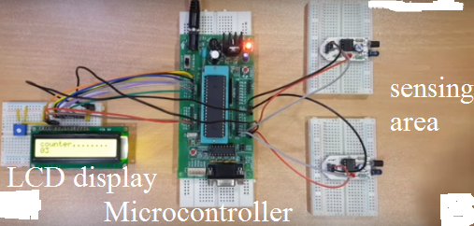

Fig.11. Hardware of people counter

1. **Conclusion**

We have demonstrated the possibility of developing the bidirectional; inexpensive people counter by deploying infrared sensor at the gates/entry or exist of any facility. By using IR sensor as triggers for a wakeup of the micro-controller, we counted number of people and the micro-controller is able to forward data for a remote access using a wireless communication. We developed an html page for user access. We have used Proteus software and c programming for simulation and hardware testing respectively. The initial results shows that compared to the mostly used cameras based people counter, our solution achieved the bidirectional ,low cost people flow counting and could be used to address privacy and high cost problem.

1. **References.**
2. Hessam Mohammadmoradi, Sirajum Munir, Omprakash Gnawali, Charles Shelton. Measuring People-Flow through Doorways using Easy-to-Install IR Array Sensors. 2017 13th International Conference on Distributed Computing in Sensor Systems
3. Byung-rak Son, Seung-chan Shin, Jung-gyu Kim, and Yong-sork Her. Implementation of the Real-Time People Counting System using Wireless Sensor Networks. International Journal of Multimedia and Ubiquitous Engineering Vol. 2, No. 3, July, 2007
4. ChengLin Liu, Liya Kong, Yan Cao, and Qinghua Huang. Motion states recognition system based on ultrasound for automatic door management. 2011 International Conference on Internet Computing and Information services
5. Bin Li, Jian Zhang, Zheng Zhang, Yong Xu. A People Counting Method Based on Head Detection and Tracking. IEEE SMARTCOMP 2014
6. Dittrich, Fabio & Soares de Oliveira, Luiz & Alceu S. Britto, Jr & Koerich, Alessandro. (2017). People Counting in Crowded and Outdoor Scenes using a Hybrid Multi-Camera Approach.
7. Oliver Sidla, Yuriy Lypetsky, Norbert Brändle, Stefan Seer. Pedestrian Detection and Tracking for Counting Applications in Crowded Situations 2006 IEEE International Conference on Advanced Video and Signal Based Surveillance (AVSS'06), 2006
8. Abdullah-Al-Wadud, M.” A human Activity Recognition System Based on Sensory Related to Object Usage. International Journal of Mechanical Aerospace, Industrial, Mechatronic and Manufacturing Engineering Vol8.1:pp34-36.
9. Martin Stubenschrott* Thomas Matyus Christian Kogle. Real-time estimation of pedestrian inflow rates from saturated sensor counting data in a complex metro station. 2015 IEEE 18th International Conference on Intelligent Transportation Systems.
10. Gerland, H., & Mcdonald, I. BCounted: Automatic People Counting and People Flow Management at Airports. Automated People Movers and Automated Transit Systems 2016. (2016).